REQUESTING FMBS WEB ACCESS

STEP 1: Log into the MWR Portal at: https://www.mwr.army.mil/
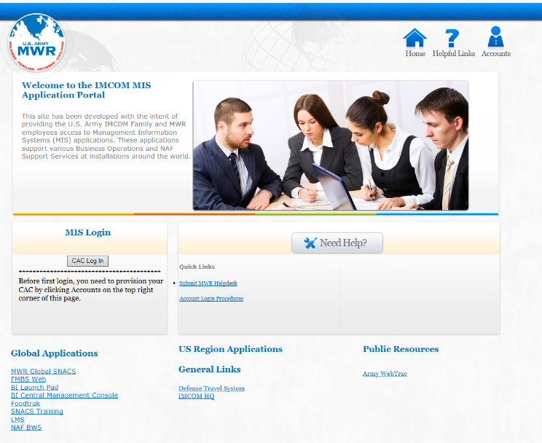
STEP 2: Click on the FMBS Web link.

Step 2

STEP 3: Select the appropriate certificate (normally e-mail certificate) and click the “OK” button.
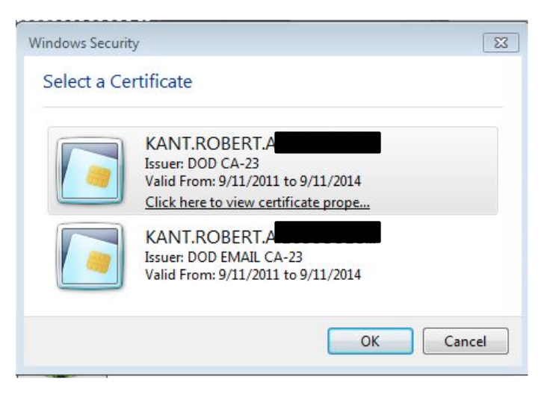

Step 3

STEP 4: If asked, enter your CAC card pin number and click the “OK” button.

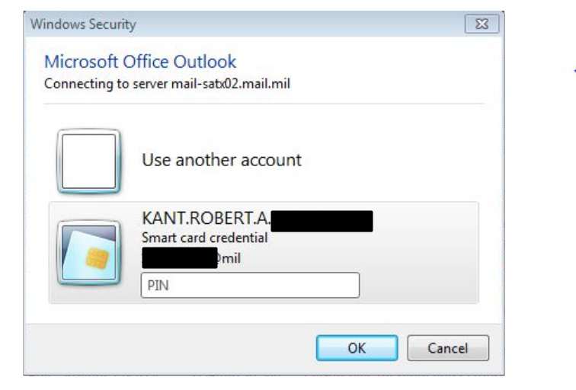

Step 4

STEP 5: Read the disclaimer statement and click the “I Agree” button. If you do not agree, exit the website and close your browser.
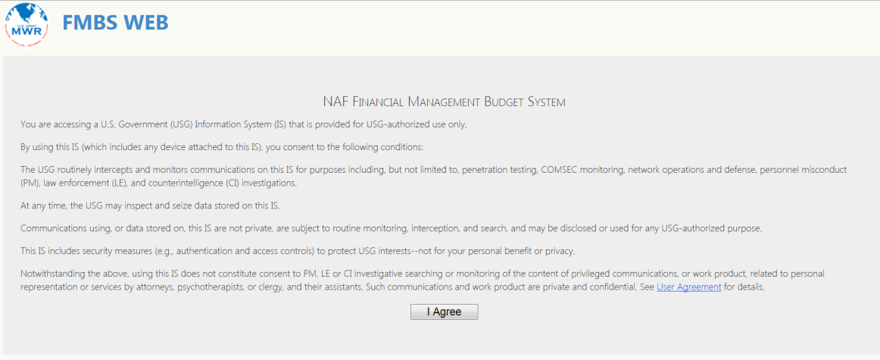

Step 5

STEP 6: The new user will receive a screen telling them that they are not a registered user of FMBS Web and they need to apply. Click on the “here” link to access the online FMBS Web New User’s Registration Form.
Step 6
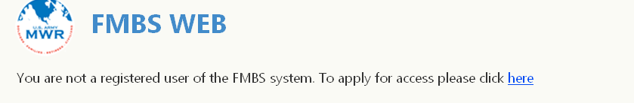

STEP 7: Complete the FMBS Web New User Registration Form.

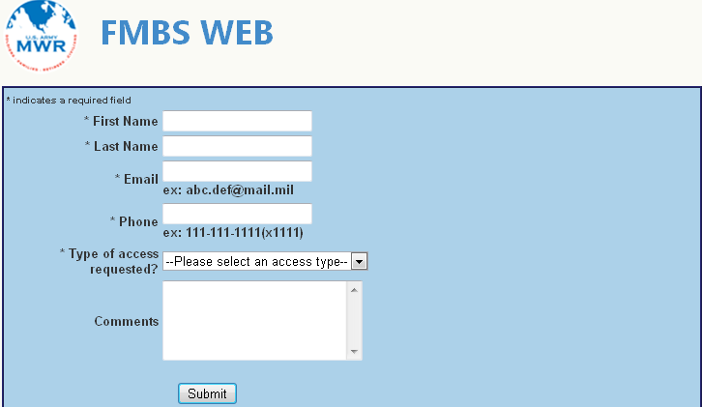
STEP 8: Click the SUBMIT button at the bottom of the application to submit the completed application to the approving authority.

Step 7

Step 8

- First Name  - Last Name  - E-mail Address (@mail.mil)  - Telephone Number | - Type of Access (from the dropdown menu select Headquarters)  - Comments: (1) enter your Division Code (2) Enter “entry only” or “entry & review” or “review only” based upon required access.

STEP 9: Confirmation of request submitted. After clicking the “Submit” button in the last step, a confirmation screen will appear indicating the request for access has been submitted.

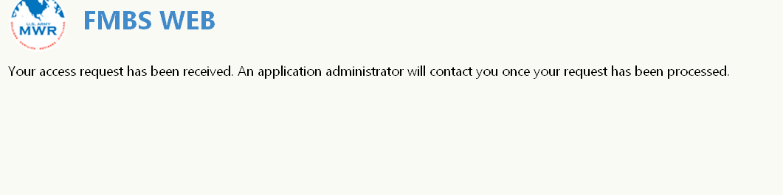

STEP 10: Notification user has access. When the user received an e-mail subject: FMBS Web Access Request Approved. It will be similar to the one below. It means the user has been granted access to FMBS Web at the indicated access level. The use should follow the instructions in Paragraph 5 (Log-In) to start using FMBS Web.

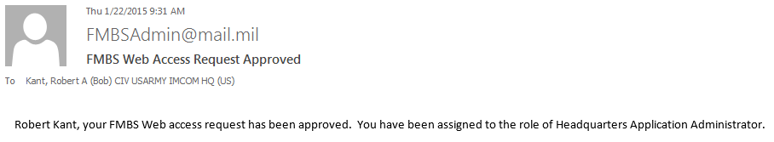

NOTE: Do NOT send e-mails to FMBSAdmin@mail.mil. This is an automated e-mail account used solely to send notification messages. It is not monitored.

